Review – Thermochemistry Unit
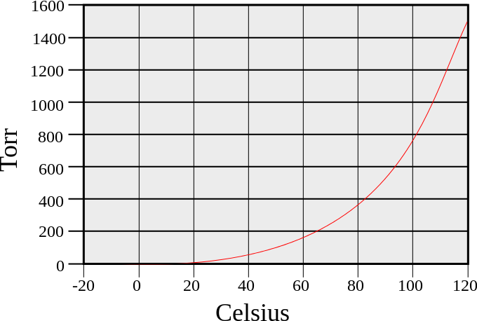
Practice – Keep in mind, this is NOT all inclusive!! Study your notes, practice sheets, quizzes, labs, etc.
1. What is the boiling point for the gas in the graph on the right?
Torr = mmHg

2. If the pressure is increased to 1200 torr, what is
the boiling point of the gas in the graph?

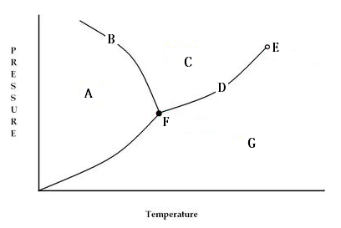

Use the graph on the left to answer the following:
3. Which letter represents the critical point?
What does ‘critical point’ mean?

4. Which letter shows the triple point?
What does triple point mean?

5. Which letter shows the liquid phase? 6. What is happening at B?
7. What phase is G? 8. Which is more dense – the solid or liquid in the diagram above?
9. Going from point A to be point G is called?
10. Going from point G to point C is called?
11. How can you change the boiling point and melting point of any substance?
12. How is evaporation different than vaporization/boiling?
13. How does kinetic energy differ from solid to liquid to gas?
14. At which state of matter would you use the formula Q = mC_{(s)}ΔT?
15. At which state of matter change would you use the formula Q = mH_{f}?
16. Which phase has low kinetic energy, is not compressible, and the molecules are close together and vibrate?

17. Define and give examples of
Radiation:
Convection:
Conduction:

Specific Heat Capacities of Various Materials
Substance | Specific Heat Capacity (J/g·ºC) | Substance | Specific Heat Capacity (J/g·ºC)
Aluminum | 0.895 | Water (solid) | 2.06
Water (liquid) | 4.18 | Water (gas) | 2.02

- What is specific heat?

- When 3.0 kg of water is cooled from 80.0°C to 10.0°C, how much heat energy is lost? **Mass must be in grams.

- How much heat is needed to raise a 0.30 kg piece of aluminum from 30.°C to 150.°C?

- How many joules are absorbed when 5 g of water melts at 0°C?

22. To what temperature change will a 50.0 g piece of glass raise if it absorbs 5275 J of heat and its specific heat is
0.50 J/g·°C?

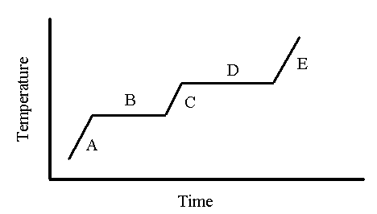
23. You have a sample of H₂O with a mass of 25.0 g at a temperature of 25.0 ◦C. How many joules of heat energy are necessary to heat it to steam that’s 120 ◦C?

24. What are 5 ways/things that change the speed of reactions?
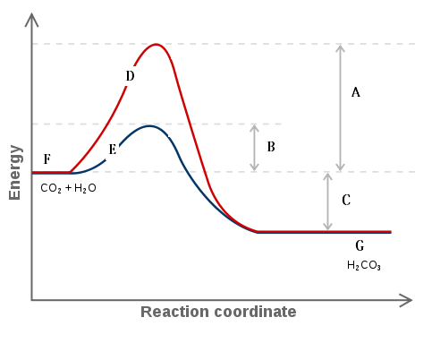

25. What is collision theory?

26. What is activation energy?

27. Does the graph to the right show an endothermic
or exothermic reaction?

28. Which letter shows the line when a catalyst is present?

29. Which letter shows the amount of activation energy needed when no catalyst is present?

30. Which letter shows the reactant side of the graph?

31. Is energy absorbed or released for the forward reaction?

32. What does letter B represent?

33. What is entropy?

34. For the reactions, identify whether ∆S is +, -, or neither.
a. H₂(g) + Cl₂(g) 2HCl(g)
b. 2KClO₃(s) 2KCl(s) + 3O₂(g)
c. N₂(g) + 3 H₂(g) 2 NH₃(g)
d. 2N₂O₅(g) 4NO₂(g) + O₂(g)

Compound | H_{f} (kJ/mol) | Compound | H_{f} (kJ/mol)
CH₄(g) | -74.8 | HCl(g) | -92.3
CO₂(g) | -393.5 | H₂O(g) | -241.8
NaCl(s) | -411.0 | SO₂(g) | -296.1
H₂O(l) | -285.8 | NH₄Cl(s) | -315.4
NaOH(s) | -569.0 | H₂S(g) | -395.2

35. Using the table above, calculate the ∆H_{f}° for the reactions:

a. CH₄(g) + 2 O₂(g) CO₂(g) + 2 H₂O(l)

b. 2 H₂O(l) + 2 SO₂(g) 2 H₂S(g) + 3 O₂(g)

c. NaOH(s) + HCl(g) NaCl(s) + H₂O(g)

- Apply the concept of kinetic energy to the various states of matter
- Define “boiling point” – identify the relationship between pressure and temperature
- Heating curve (stair-step phase change diagram) applications:
  - Use a diagram to identify solids, liquids, gases, melting/freezing points, vaporization/condensation points, etc…
  - Define and apply enthalpy of fusion and enthalpy of vaporization
  - Calculations…
- Explain the concept of “phase change” (energy and temperature) and know terms
- Define and apply the concept of “specific heat”
- Define and apply the concept of “energy” with respect to changes in temperature and the state of matter
- Phase change and heat calculations:
  - Calculate the amount of energy given off or absorbed for a temperature change
  - Calculate the amount of energy required for a phase change
  - Calculate for any missing variable
- Complete multi-step calculations
- Vapor pressure curve diagram applications:
  - Compare and contrast boiling points for given substances
  - Identify boiling point for given conditions
  - Identify normal boiling point
- Phase change diagram applications:
  - Identify solid, liquid, gas, melting point, boiling point, triple point, critical point, etc…
  - Determine what occurs as pressure and temperature are changed
- Identify the factors that influence the rate of reaction
- Explain the concept of the “collision theory” – apply the concept to given situations
- Activation energy diagram applications:
  - Identify reactants, products, activated complex, activation energy, ΔH, etc…
  - Apply diagrams for the forward and reverse reactions
  - Define and apply the concept of a “catalyst”
  - Differentiate between energy levels for reactants and products
  - Determine if ΔH is positive or negative for a given diagram
  - Identify reactions as exothermic or endothermic – know common examples with respect to phase changes
- Define and apply the concept of “enthalpy” - use given phase changes to determine enthalpy
- Calculate ΔH_{reaction} using given heats of formation
- Define and apply the concept of “entropy” – use given phase changes and mole ratio comparisons to determine if entropy increases or decreases

This information will be given on the test:

Formulas and Constants:

1 atm = 760 torr = 760 mmHg = 101.325 kPa

1 cal = 4.18 J

K = ⁰C + 273

ΔH_{reaction} = Σ ΔH_{f (products)} - Σ ΔH_{f (reactants)}

Q = mH

Q = mCΔT

The following information is applicable for water:

C solid = 2.06 J/g∙°C C liquid = 4.18 J/g∙°C C gas = 2.02 J/g∙°C

H_{f} = 334 J/g H_{v} = 2260 J/g

mp = 0.0 °C bp = 100.0 °C

