**Spring Exam Comprehensive Review**

*\*Keep in mind,* ***this review is NOT all inclusive****!! Study your notes, homework, quizzes, labs, and most importantly your TESTS!*

**Unit 8: Stoichiometry**

**Hydrates:**

-Be able to name hydrates, write the formula for a given hydrate, and determine the molar mass of hydrates.

-Be able to find the value of “n” for a hydrate.

-Be able to give the correct formula for the hydrate given either mass or %

Name the following:

1. Li2SO4 •5H2O lithium sulfate pentahydrate 2. CuI2 •6H2O copper (II) hexahydrate

Write the formula and determine the molar mass for each:

3. Iron (IV) sulfate tetrahydrate 4. zinc chloride trihydrate

Formula: Fe(SO4)2 •4H2O Formula: ZnCl2•3H2O

MM: 320.05 g/mol MM: 190.35 g/mol

**% Composition**: Be able to do % composition problems. Formula is given!

5. If 405 grams of magnesium sulfate heptahydrate is completely dehydrated, how many grams of anhydrate magnesium

sulfate salt will remain? MgSO4 • *7* H2O

(% in decimal form)(total mass of the sample) 🡪 (0.4883)(405) = **197.76 g MgSO4 salt is in the sample!**

When working **stoichiometry problems**, you always start with a BALANCED chemical equation!

1 mole of any **gas** has a volume of 22.4 L at STP. (**You don't have to memorize this)**

1 mole of any substance equals the MOLAR MASS of the substance in grams.

Be able to use the mole map below to help convert between substances. Be able to do any stoichiometry problems given!

volume A volume B

Mole A Mole B

mass A particles A mass B particle B

What does it mean to use a mole ratio? Why is important?

Use coefficients in a balanced equation to switch from mole of ONE substance to ANOTHER substance.

Work the following stoichiometry problems:

6. The formation of aluminum oxide is from the constituent elements aluminum and oxygen. How many moles of

aluminum are needed to form 2.30 moles of aluminum oxide? *Make sure chemical equation is BALANCED!

4 Al + 3O2🡪 2 Al2O3

7. How many liters of hydrogen gas are produced if 15.9 grams of hydrochloric acid reacts with excess zinc metal at STP?

Zn + 2HCl 🡪 ZnCl2 + H2

**2**

**Limiting Reactants**

What is a limiting reactant? Reactant that is USED UP 1ST. Choose the smaller of the 2 products. This states that is the most product you can make!

What are the other reactants called? Excess reactants.

Work the following limiting reactant problem:

8. What is the maximum amount in grams of copper (I) sulfide that can be formed when 80.0 g. of copper reacts with

25.0 g. of sulfur?

**🡨 LR, b/c produced the smaller amount.**

$25.0 g S x \frac{1 mol S}{32.06g S}x\frac{1 mol {Cu}_{2}S}{1 mol S}x\frac{159.16 g {Cu}_{2}S}{1 mol {Cu}_{2}S}=124.0 g {Cu}_{2}S$

**Percent Yield**

Define theoretical yield: MAXIMUM yield possible when CALCULATED! Use stoichiometry ALWAYS to find theoretical.

Define actual yield: ACTUAL yield obtained in a lab setting. Yield from the experiment itself.

Write the equation for percent yield: (**You don't have to memorize this)**

**\*\*Yields are ALWAYS products\*\***

Work the following percent yield problem:

9. Methanol can be produced through the reaction of CO and H2 in the presence of a catalyst. If 75.0 g. of CO reacts to

produce **68.4 g.** of CH3OH, what is the percent yield of CH3OH? CO + 2H2 🡪 CH3OH

actual 75.0 g ??? g

🡨 Theoretical yield

$\% yield= \frac{actual}{theoretical}x 100 → \frac{68.4 g}{85.8 g}x 100=$**79.72%**

**Unit 9: Molecular Geometry**

**Chemical Bonds**

-Ionic bonds form between Metal (cation) and Nonmetal (anion). Electrons are TRANSFERRED! An ionic compound is also called a

salt.

-Covalent bonds form between 2 or more nonmetals. Electrons are SHARED! When electrons are shared unequally the bond is polar.

When they are shared equally, as in diatomic elements, the bond is nonpolar.

Name the 7 diatomic elements: H2  N2 O2 Cl2 F2 Br2 I2

List 3 properties of IONIC compounds: List 3 properties of COVALENT compounds:

-High melting point -typically low melting point

-Conducts electricity ONLY in molten or aqueous state -does not conduct electricity at all

-Very brittle -can be solid, liquid, or gas at room temperature

List 3 properties of METALLIC bonds:

-great conductors of heat and electricity

-HIGHLY malleable and ductile

-VERY high melting point and high density

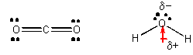VSEPR theory can predict the shape of molecules because electrons REPEL each other. To distinguish linear from bent, look for shared/lone pairs on the central/terminal atom. For example, CO2 is LINEAR whereas H2O is BENT. Which molecule is polar?

We can determine the **polarity** of a molecule by looking at the Lewis Dot Structure and following these rules:

1. If the central atom has no lone pairs and has all the same types of atoms attached to it, then the molecule is NONPOLAR.
2. If the central atom has no lone pairs but different atoms attached to it, the molecule is POLAR.
3. If the central atom has lone pairs, the molecule is POLAR.

Use the NASL method to draw Lewis structures, determine the molecular geometry (shape), and finally state whether if it’s polar or

nonpolar for the following:

|  |  |  |  |
| --- | --- | --- | --- |
| H2 | N2 | CF4 | NH3 |
| N: 2(2) = 4  A: 2(1) = 2  S: 4-2 =2 🡪1  http://www.visionlearning.com/img/library/large_images/image_10245.jpgL: 2-2 =0  Shape: liner  Polarity: NP | N: 2(8)= 16  A: 2(5) = 10  S:16-10 = 6 🡪3  L:10-6 = 4🡪2  Shape: liner  Polarity: NP | N: 1(8)+4(8) =40  A:1(4) + 4(7) = 32  http://www.kentchemistry.com/links/bonding/covale6.gifS: 40-32= 8 🡪 4  L: 32-8 = 24 🡪 12  Shape: tetrahedral  Polarity: NP | N: 1(8) + 3(2) = 14  A: 1(5) + 3(1) =8  S:14- 8 = 6 🡪 3  https://chem.libretexts.org/@api/deki/files/39118/768e2d063688200c5482e54c7905ab81.jpg?revision=1L: 8-6 = 2 🡪 1  Shape: trigonal pyramidal  Polarity: P |
|
|
|

**Unit 10: Gases**

Define Volume: Space occupied by matter.

Define Pressure: The constant bombardment of particles against the wall of the container.

Write the equations for the following gas laws and also state whether if it’s INVERSE or DIRECT (if appropriate):

(These equations don't have to be memorized but you need to be able to understand them)

1. Dalton's Law: Ptotal = Pa+Pb+…. 5. Gay-Lussac's Law: P1 / T1 = P2 / T2 (direct)

2. Boyle's Law: P1V1 = P2V2 (inverse) 6. Avogadro's Principle: V1 / n1 = V2 / n2 (direct)

3. Charle's Law: V1 / T1 = V2 / T2 (direct) 7. Graham’s Gas Law:

4. Combined gas law: P1V1 = P2V2 8. Ideal Gas Law: PV = nRT

n1T1 = n2T2

Based on the unit of the ideal gas law constant R, what are the units of the other variables in the equation?

P= atm V= L n= mole T= K

Work the following gas law problems:

1. A chemist collects a sample of hydrogen. She collects 125 mL at 1 atm. What would be the volume of the gas when

the pressure is 768 mm Hg?

🡪 (760mmHg)(125mL) = (768mmHg)V2 🡪 **V2 = 123.7 mL**

2. A 250.0 mL sample of gas is at STP. What would be the pressure if the temperature was doubled and the volume was decreased by one-third? *Combined gas law problem!

V1=250.0 mL V2=250.0 mL x 2/3 = 166.7 mL P1V1 = P2V2 🡪 (1)(250.0) = P2(166.7) 🡪 **P2 = 3.00 atm**

T1= 273K T2= 273K x 2 = 546 K n1T1 = n2T2 273 546

P1= 1atm P2=? atm

3. At what temperature **(in oC**) will 5.00 g of chlorine gas exert a pressure of 900. mmHg at a volume of 750. mL?

$5.00 g {Cl}_{2}x \frac{{1 mol Cl}_{2}}{70.9 g {Cl}_{2} }$ = 0.0705 mol PV=nRT

$900 mmHg x \frac{1 atm}{760 mmHg}=1.18 atm$ (1.18)(0.750) = (0.0705)(0.0821)T 🡪 T = 152.9 K

750. mL 🡪 0.750 L T = 152.9 – 273 = **-120. oC**

**\*\*TEMPERATURE MUST ALWAYS BE IN KELVIN\*\***

**Unit 11: Thermochemistry**

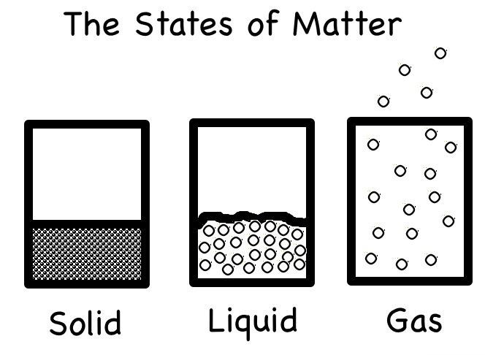

|  |  |  |  |
| --- | --- | --- | --- |
|  | Solid | Liquid | Gas |
| Shape | Definite | Indefinite | indefinite |
| Volume | Definite | definite | indefinite |
| Particle attraction | Strong | Medium | none |
| Distance between particles | Very close | Medium | Far apart |

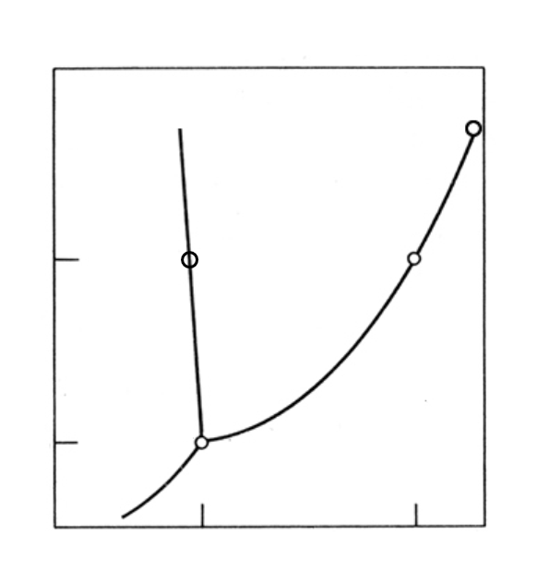

Label the following phase diagram. Include the axes, important points, phase changes, and states of matter.

Critical point

liquid

Normal MP

Normal BP

solid

gas

Triple point

Define Kinetic Molecular Theory: particles are always in constant motion.

Absolute zero is the point at which there is no molecular movement.

Show the conversion between oC and K: K = 0C + 273

Explain the difference between vaporization and evaporation:

-vaporization is the change of liquid to gas AT the boiling point.

-evaporation is the change of liquid to gas BELOW boiling point.

What does the slope of the "melting line" tell us about the density of the solid and liquid?

Depending of negative of positive slope, it lets us know which phase is DENSER.

What is STP? Standard temperature and pressure

1 atm = 101.3 kPa = 760 mmHg (**You don't have to memorize these)**

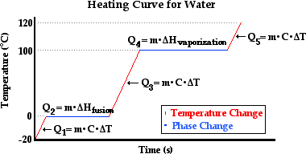Label the following heating curve with the phases, names of the phase changes, and the equations that are used to calculate the heat energy (q): (**Equations will be given)**

Write what each variable stands for:

q = heat (J)

c = specific heat (J/goC)

m = mass (g)

ΔT = change in temperature (oC)

Hf = heat of fusion (J/g)

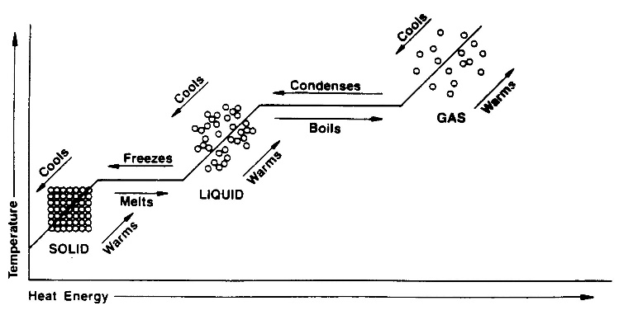Hv = heat of vaporization (J/g)

Define Endothermic: absorption of heat (+ΔH)

Define Exothermic: release of heat (-ΔH)

**\*\*BE ABLE TO WORK ENERGY AND HEAT PROBLEMS\*\***

What is activation energy?

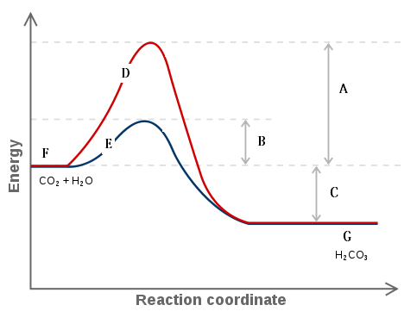Energy required to start the reaction. Needed to reach activated complex.

Does the graph to the right show an endothermic

or exothermic reaction? EXOTHERMIC

Which letter shows the line when a catalyst is present? E

Which letter shows the amount of activation energy needed

when no catalyst is present? A

Which letter shows the reactant side of the graph? F

Is energy absorbed or released for the forward reaction? Released

What does letter B represent? Activation energy with catalyst added

What is entropy? Measurement of disorder and chaos in a reaction.

|  |  |  |  |
| --- | --- | --- | --- |
| **Compound** | **Hf (kJ/mol)** | **Compound** | **Hf (kJ/mol)** |
| CH4(g) | -74.8 | HCl(g) | -92.3 |
| CO2(g) | -393.5 | H2O(g) | -241.8 |
| NaCl(s) | -411.0 | SO2(g) | -296.1 |
| H2O(l) | -285.8 | NH4Cl(s) | -315.4 |
| NaOH(s) | -569.0 | H2S(g) | -395.2 |

For the reactions, identify whether ∆S is +, -, or neither.

a. H2(g) + Cl2(g) 🡪2HCl(g) neither

b. 2KClO3(s) 🡪 2KCl(s) + 3O2(g) +

c. N2(g) + 3 H2(g) 🡪 2 NH3(g) -

d. 2N2O5(g) 🡪 4NO2(g) + O2(g) +

Using the table on the RIGHT, calculate the ∆Hf° for the reactions: ∆Hf° = P-R

a. CH4(g) + 2 O2(g) 🡪 CO2(g) + 2 H2O(l)

[1(-393.5)+2(-285.8)] - [1(-74.8)+2(0)]= **-890.3 kJ**

**exothermic**

b. 2 H2O(l) + 2 SO2(g)  🡪 2 H2S(g) + 3 O2(g)

[2(-395.2)+3(0)] - [2(-285.8)+2(-296.1)]= **373.4 kJ**

**endothermic**

**Unit 12: Solutions**

Define solution: homogeneous mixture made of a solute and a solvent.

Define solute: substance that is dissolved.

Define solvent: substance that does the dissolving.

**Factors influencing solubility.** Fill in the following table with what will increase the solubility:

|  |  |  |
| --- | --- | --- |
|  | **SOLIDS DISSOLVED IN LIQUIDS** | **GASES DISSOLVED IN LIQUIDS** |
| **TEMPERATURE** | **As temp ↑ , solubility ↑** | **As temp ↑ , solubility ↓** |
| **PRESSURE** | **N/A** | **As pressure ↑ , solubility ↑** |
| **AGITATION** | **As agitation ↑ , solubility ↑** | **As agitation ↑ , solubility ↓** |

How can you make a concentrated solution more dilute? Add more solvent (water).

Write the following equations and name each variable with units: (These formulas will be given for the final)

1. Molarity (M): M = mol/L

2. molality (m): m=mol/ kg

3. Dilution: M1V1=M2V2

4. Percent Mass:% mass = (gsolute/ gsolution) x 100%

Work out the following solution problems:

1. What mass of magnesium chloride (in grams) are required to make 250. mL of a 0.650 M solution?

Mass=? G MgCl2  M= 0.650M $0.163 mol {MgCl}_{2} x \frac{95.21 g{MgCl}_{2} }{1 mol {MgCl}_{2}}=15.5 grams$

V= 250. mL 🡪 0.250L M=mol/L

1st find ? mol 0.650 = mol/ 0.250 🡪 mol = 0.163 mol

2. How much water would you have to add to 65.0 g of glucose, C6H12O6, to make a 15.00 % solution?

gsolvent= ? g water % mass = gsolute x 100 🡪 15.00% = 65.0g x 100 🡪 gsolution = 433 g

gsolute= 65.0g C6H12O6 gsolution gsolution

% mass= 15.00%

Gsolvent= gsolution –gsolute = 433-65 = **368g water**

3. What volume (in mL) of water would have to be added to 350.0 mL of 0.250 M KCl to give a solution with a concentration of 0.100 M?

Vwater= ? mL V1= 350.0 mL V2 =? mL M1V1=M2V2 🡪 (0.250)(350.0) = (0.100)V2

V2= ? mL M1 = 0.250 M M2 = 0.100 M V2 = 875 mL

Vwater= V2-V1 = 875mL- 350 mL = **525 mL water**

1. Calculate the molality of a solution with 1.47 moles in 1670 g of water.

mol= 1.47 mol m= mol/ kg 🡪 m = 1.47 mol/ 1.67 kg 🡪 **m= 0.88 m**

1670g water 🡪 1.67 kg water

?? m

Define colligative properties: The properties that determine a change in the freezing point/ boiling point of the SOLVENT

When a SOLUTE is added.

Why does the boiling point of a solvent increase when a solute is added? It introduces MORE IMF (attractive forces) that

Needs to be broken to boil the solvent and requires more energy added.

Why does the freezing point of a solvent decrease when a solute is added? It disrupts the crystal formation of solvent and

requires more energy to be removed in order to freeze.

Define a saturated solution: the MAXIMUM amount of solute added to the solvent to stay dissolved.

Define an unsaturated solution: LESS than the maximum amount of solute that can be added to the solvent.

Define a supersaturated solution: MORE than the maximum amount of solute the solvent can theoretically hold.

**\*\*BE ABLE TO READ A SOLUBILITY CURVE\*\***

**Unit 13: Acids and Bases**

**\*\*REVIEW NAMING ACIDS/BASES\*\***

*List the properties of acids:

Sour tasting, conducts electricity (electrolyte), and turns litmus paper red.

*List the properties of bases:

Bitter tasting, feels slippery, conducts electricity as well, and turns litmus paper blue.

How is a salt made? Neutralization reaction. Acid reacts with a base to produce salt and water.

Define amphoteric: A substance that can act as an acid or a base.

What is the Arrhenius definition of an acid and base?

Acids form H+ in water. Bases form OH- in water.

What is the Bronsted-Lowry definition of an acid and base?

Acids donates protons (H+). Bases accepts protons (H+).

What is the Lewis definition of an acid and base?

Acids accepts electron pairs. Bases donates electron pairs.

If the pH is less than 7, the solution is acidic.

If the pH is greater than 7, the solution is basic.

If the pH is 7, the solution is neutral.

What do the brackets mean? [H+] concentration or molarity of that ion.

Fill in the blanks to the following equations: **(will be given on final)**

pH + pOH = 14 pH = -log[H+]

[H+] = 10-pH  [H+] [OH-]=1 x 10-14

pOH = -log[OH-] [OH-] = 10-pOH

Work the following problem:

1. Given [H+l] = 5.5 x 10-4 M, find the following and state whether this solution is acidic or basic**.**

[H+1] = 5.5 x 10-4 M

[OH-1] = 10-10.74 = 1.8 x 10-11 M

pH = -log(5.5 x 10-4 M) = 3.26

pOH = 14-3.26 = 10.74 Acidic or Basic? **ACIDIC**

In salt hydrolysis, the cation of a salt comes from its parent BASE (acid/base). The anion of a salt comes from its parent ACID (acid/base).

Work the following salt hydrolysis problem:

|  |  |  |
| --- | --- | --- |
| Salt | Parent Acid | Parent Base |
| **SrCl2** | HCl | Sr(OH)2 |

What is the purpose of a titration?

To determine an unknown concentration of H+/OH- by neutralizing it with a known base or acid.

What is the titration formula? **(Will be given for final)**

(H+)MaVa = (OH-)MbVb

Work the following titration problem:

1. In a titration 21.4 mL of a 0.0154 M solution of Ba(OH)2 is added to a 20.0 mL sample of HCl. What is the molarity of HCl?
   1. Balanced chemical reaction for titration:

2HCl + Ba(OH)2 🡪 BaCl2 + 2HOH

* 1. Titration calculation:

(H+)MaVa = (OH-)MbVb

(1)Ma(20.0) = (2)(0.0154)(21.4) 🡪 **Ma = 0.0330 M**