Spring Final Formulas

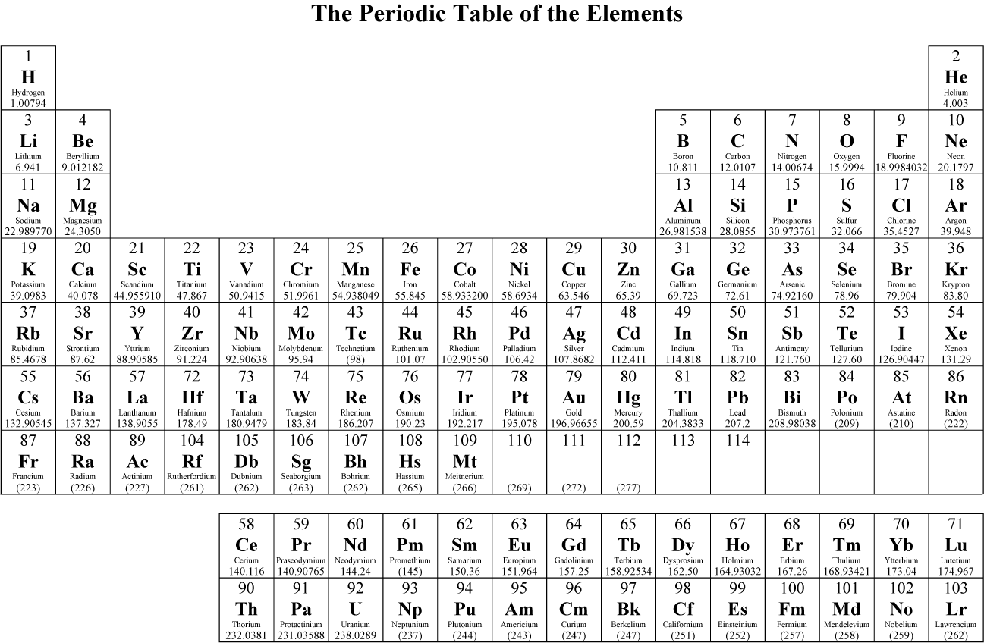

Unit 8 Stoichiometry

$\% composition= \frac{part}{whole}x 100$ $n= \frac{mol water}{mol salt}$
1 mol = 22.4 L $\% yield= \frac{actual}{theoretical}x 100$
1 mol = 6.02 x 10²³ particles

volume A volume B

Mole A Mole B

Mass A particles A mass B particle B

Unit 10 Gas Laws

Conversion given: 1 atm = 760 mmHg = 101.3 kPa K = ⁰C +273
P_{total} = P_{a} + P_{b} + P_{c} + ….. PV = nRT R = 0.0821 L atm/ K mol

$\frac{P_{1}V_{1}}{n_{1}T_{1}}= \frac{P_{2}V_{2}}{n_{2}T_{2}}$ $\frac{r_{1}}{r_{2}}= \sqrt{\frac{M_{2}}{M_{1}}}$
$P_{1}V_{1}=P_{2}V_{2}$ $\frac{V_{1}}{T_{1}}= \frac{V_{2}}{T_{2}}$ $\frac{P_{1}}{T_{1}}= \frac{P_{2}}{T_{2}}$ $\frac{V_{1}}{n_{1}}= \frac{V_{2}}{n_{2}}$

Unit 11 Thermochemistry
The following information is applicable for water:

H_{f} = 334 J/g C_{solid} = 2.06 J/gºC
H_{v} = 2260 J/g C_{liquid} = 4.18 J/gºC
C_{gas} = 2.02 J/gºC
1 atm = 101.3 kPa = 760 mmHg = 760 torr

Q = mCΔT Q=mH_{f} Q=mH_{v}

ΔH = Σ P - Σ R

Unit 12 Solutions

Molarity: $M=\frac{mol}{L}$ Molality: $m= \frac{mol}{kg}$

M₁V₁ = M₂V₂ V_{water} = V₂ – V₁

% mass = $\frac{g_{solute}}{g_{solution}} x 100\%$ g_{solution} = g_{solute} + g_{solvent}

Unit 13 Acids/ Bases

pH = -log [H⁺] [H⁺] = 10^{-pH} (H⁺)M_{A}V_{A} = (OH⁻)M_{B}V_{B}

pOH = -log [OH⁻] [OH⁻] = 10^{-pOH}

pH + pOH = 14 [H⁺][OH⁻] = 1 x 10⁻¹⁴

