**Chemistry I Review Group Quiz: Unit 12-13**

**Solutions and Acids/ Bases**

**Unit 12: Solutions**

1) Which of the following substances is soluble in water?

A) NaNO3 B) CH4 C) CO2 D) methane (hydrocarbon)

2) What is the molarity of a solution containing 8 grams of a solute in 500 mL of solution?

(MM of solute = 24 g/mol)

A) 0.7 M B) 0.1 M C) 0.5 M D) 1 M

3) What is the molality of a solution with 2.5 grams Na2SO4 with a mass of 1200 grams of water?

(MM Na2SO4 = 142 g/mol)

A) 0.55 m B) 0.015 m C) 15.0 m D) 2.08 m

4) What volume (in mL) of 3M HCl is needed to make 300 mL of 0.1M HCl?

A) 10 mL B) 30 mL C) 90 mL D) 9 mL E) 100 mL

5) If more solute is added to a solution, this would cause the boiling point to _______ and the freezing point to _________.

A) increase, increase B) increase, decrease

C) decrease, decrease D) decrease, increase

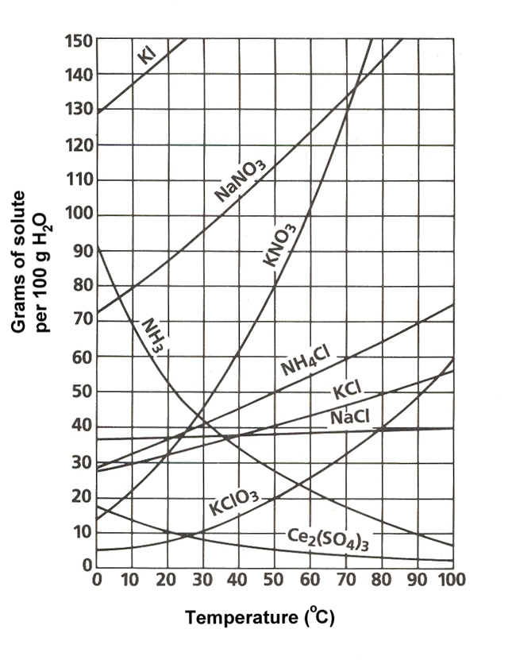6) According to the solubility curve below, 65 grams of ammonium chloride in 100 grams of water at 70 degrees Celsius will be considered a(n) _______ solution.

A) unsaturated

B) saturated

C) supersaturated

D) dilute

7) Using the same solubility curve, if about 15 g of

potassium chlorate can dissolve in 100 g of water

at 40 degrees Celsius, how many grams of water

must be added to dissolve 45 g of this solute. The

temperature remains the same. *Hint: set up proportion.

1. 200 g
2. 300 g
3. 400 g
4. 500 g

8) Calculate the percent by mass of the solute when 175.5 g of CaCl2 is dissolved in 1150 g of water.

1. 86.76 % B) 15.26 % C) 13.24 % D) 18.01 %

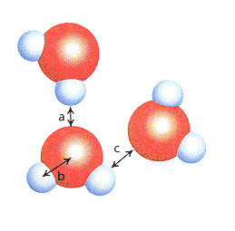9) Which letter(s) represent(s) hydrogen bonding for picture on the right?

A) c only

B) b only

C) a and b

D) a and c

10) To how much water, should 55.5 mL of 12 M hydrochloric acid be added to produce a 2.0 M solution?

1. 333.0 mL
2. 277.5 mL
3. 9.3 mL
4. 111.0 mL

**Unit 13: Acids & Bases**

11) If the [H+1] in a solution is 1 x 10-1 mol/L, what is the [OH-1]?

A) 1 x 10-13 mol/L B) 1 x 10-1 mol/L C) 1 x 10-15 mol/L D) cannot be determined

12) If the pH is 9.0, what is the concentration of hydroxide ion?

A) 1 x 10-14 M B) 1 x 10-1 M C) 1 x 10-7 M D) 1 x 10-5 M

13) In the reaction, NH4+1 + H2O 🡨🡪 NH3 + H3O+1, water is acting as a(n) __________.

A) Bronsted-Lowry base

B) Arrhenius base

C) Bronsted-Lowry acid

D) Arrhenius acid

14) Which of these solutions is the most basic? HINT: find pH!!

A) [H+] = 1 x 10-2M

B) [OH-] = 1 x 10-13M

C) [OH-] = 1 x 10-4M

D) [H+] = 1 x 10-11M

15) What is the name of H2SO3?

A) hydrosulfite acid

B) hyposulfuric acid

C) sulfurous acid

D) sulfuric acid

E) hydrosulfuric acid

16) A scientist titrates 50 mL of an unknown concentration of HCl with 45 mL of 0.1 M NaOH. What is the concentration of the HCl?

A) 11.11 M

B) 5.56 M

C) 0.09 M

D) Not enough information

17) Write the formula for manganese (II) hydroxide.

1. MnOH
2. Mn2OH
3. MnOH2
4. Mn(OH)2

18) Calculate the [H+] concentration of a solution with a pH = 9.25.

1. 5.62 x 10-10 M
2. 1.45 x 10-7 M
3. 7.99 x 10-1 M
4. 4.82 x 10-13 M

19) What is the conjugate acid of the following base: OH- ?

1. O-2
2. H2O
3. H3O+
4. H+

20) Which of the following is matched correctly according to the *Arrhenius theory*?

* 1. HF – base
  2. NH3C2H3O2 – acid
  3. Ca(OH)2 – base
  4. K3PO4 – acid