Chemistry I Review Group Quiz: Unit 10-11
Gas Laws and Thermochemistry

Unit 10: Gas Laws
1) A gas occupies a volume of 0.7 L at 10.1 kPa. What volume will the gas occupy at 101kPa?

A) 4 L B) 0.7 L C) 7 L D) 0.07 L

2) As the temperature of a gas in a balloon decreases, ____________.

A) the pressure increases
B) the volume increases
C) the average kinetic energy of the gas decreases
D) all of the above

3) At constant temperature and pressure, gas volume is directly proportional to the ___________.

A) number of moles of the gas
B) density of the gas at STP
C) rate of diffusion
D) molar mass of the gas

4) What type of relationship is seen between pressure and volume for gas laws?

A) direct B) inverse C) exponential D) positive

5) A reaction at 86.0⁰C in a 250 mL expandable container. What will be the temperature if the volume is increased to 500.0 mL.

A) 100k B) 172 K C) 718 K D) 1467 K

6) Convert 1.25 atm to mmHg.

A) 126.6 mmHg B) 608 mmHg C) 950. mmHg D) 81.06 mmHg

7) A sample of gas contains 0.875 moles of a gas at 0.900 atm and 20.0⁰C. What is the volume of this gas?

A) 2.21 x 10⁻⁴ L B) 23.4 L C) 2.92 x 10⁻⁴ L D) 1.60 L

8) Which of the following conditions would cause a gas to LEAST likely be considered an “ideal gas”? Think about the 2 conditions.
- High temperature and low pressure
- Low temperature and high pressure
- Low temperature and low pressure
- Gases ALWAYS behave ideally

9) At STP, which gas would have the highest rate of effusion? *Graham’s Law
A) nitrogen monoxide B) nitrogen gas C) krypton D) chlorine gas
10) What is the mass, in grams, of 0.215 L of nitrogen monoxide at STP?
- 0.030 g
- 0.288 g
- 1.47 g
- 9.59 g

Unit 11: Thermochemistry
11) How much heat does it take to warm 16.0 g of pure water from 90.0 ⁰C to 100.0 ⁰C?
(Specific heat of water = 4.18 J/g ⁰C)

A) 160 joules B) 16.0 joules C) 669 joules D) 66.9 joules

12) As the temperature of a sample of matter is increased, what happens to the average kinetic energy of the particles in the sample?

A) It does not change.
B) It increases.
C) It decreases.
D) Not enough information.

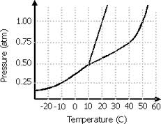
13) Using the following phase diagram, what is the normal melting point of the substance?
- 20 ⁰C
- 50 ⁰C
- 10 ⁰C
- 55 ⁰C

14) Using the same phase diagram from above, what phase change will occur as a liquid at 0.80 atm and 30 ⁰C undergoes a pressure drop to 0.25 atm?
- Vaporization B) sublimation C) melting D) condensation
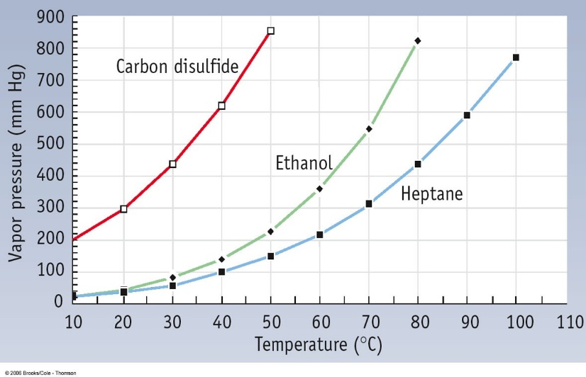
15) Using the diagram below, what is the boiling point of ethanol at normal pressure? Give an approximation.

- 45 ◦C B) 55 ◦C C) 65 ◦C D) 75 ◦C
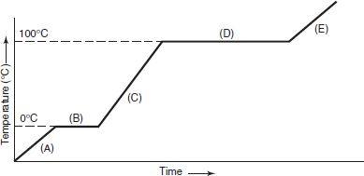
16) Using the heating curve and the information provided, calculate the total amount of energy required to raise 10.0 grams of H₂O from -5 °C to 15 °C. *Multi-step

H_{f} = 334 J/g C_{solid} = 2.06 J/gºC
H_{v} = 2260 J/g C_{liquid} = 4.18 J/gºC
C_{gas} = 2.02 J/gºC

A) 836 J B) 3540 J C) 4070 J D) 4588 J

17) Using the same heating curve above, determine which of the following statements is correct.
- Letters A, C, and E represent phase changes
- Letters B and D represent freezing
- Letters B, C, and D represent changes in temperature
- Letters B and D represents phase changes

18) A pan of water is placed in the oven for a few minutes at a high temperature. When you reach in, you almost burn your hand on the metal pan, but the water is barely warmed. What is the best way to explain this?
- Water has a high specific heat and metal has a low specific heat
- Water has a low specific heat and metal has a high specific heat
- Water and metal both have fairly high specific heats
- Water is a conductor and metal is an insulator
19) In which system does entropy decrease (ΔS = -)?
- ice melting
- liquid iodine vaporizing
- methane gas crystallizing to become solid methane
- salt melting at high temperatures
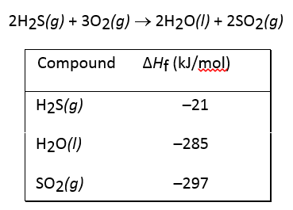
20) Using the information below, what is the heat (enthalpy) of reaction for this equation?
ΔH = Σ P – Σ R

- -1122 kJ Exothermic
- -603 kJ Endothermic
- +561 kJ Exothermic
- +1122 kJ Endothermic

