Quiz 2 Review

**Remember, this is just a quick review. The quiz covers EVERYTHING from notes 12.3 and 12.4. Make sure you study your NOTES!

- What is the difference between diluted and concentrated solution? Use chemistry terms that you’ve learned this unit.

- What can you do to a solution to dilute it?

- Name all 3 ways to quantify/ represent concentration:

- How do you find the mass in grams of the solution? Which 2 parts?

- Calculate the amount of water needed to produce a 65% solution with 105 grams of sodium acetate.

- What is the percent mass if you mix 88 grams of solute with 0.35 kg of water?

- What is the new concentration of 50 mL of 18 M hydrofluoric acid if it was diluted to a 0.445 L solution?

- How much water is needed to dilute 75 mL of 8.5 M potassium chloride to a produce a new concentration of 2.5 M?

- Calculate the final volume if 0.50 M with 25 mL of a solution was diluted to a concentration of 0.10 M?

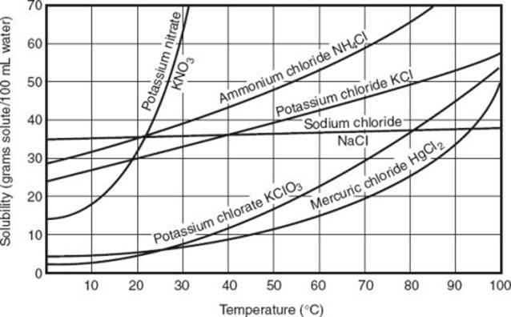

- If mercuric chloride was cooled from 100 ⁰C to 60⁰C, how many grams of the salt will fall out of solution?

- How much ammonium chloride can dissolve at 75 ⁰C?

- At 70⁰C, how much potassium chlorate can dissolve in 285 grams of water?

- Approximate at which temperature will 20 grams of potassium nitrate dissolve completely?

- If there are 20 grams of potassium chloride currently at 30⁰C, what kind of solution is this?

- Which substance is the LEAST soluble at 10⁰C?

