Final Exam Practice Test
Unit 1 Practice

Mass Measurements of a Platinum Cylinder
Balance | First measure  (g) | Second Measure  (g) | Third Measure  (g) | Fourth Measure  (g)
Q | 24.94 | 25.26 | 25.29 | 24.51
R | 25.50 | 24.50 | 25.00 | 24.49
S | 24.99 | 24.99 | 25.20 | 24.92
T | 24.99 | 25.03 | 24.98 | 25.02
- The table shows four mass readings of one object as measured by four different balances. Which balance produced the most precise measurements?
(A) Q
(B) R
(C) S
(D) T

- The reason for wafting or fanning a small amount of chemical vapors toward the nose as a means to detect odors in a test tube is to —

(A) avoid experimental error from excessive loss of mass of reactants or products.
(B) avoid splashing chemicals into the face of any person.
(C) protect the respiratory tract against potentially harmful vapors.
(D) determine the relative strength of the odor before smelling directly.

- Choose the correct answer for the following problem.
3.56 x 10⁻⁴ L + 2.11 x 10⁻³ L
(A) 2.47 x 10⁻⁴ L (B) 5.67 x 10⁻⁴ L (C) 3.77 x 10⁻⁴ L (D) 2.47 x 10⁻³ L

- Choose the correct answer for the following problem.

3.00 x 10⁸ m³ / 5.0 x 10⁻² m²
(A) 6 x 10¹⁰ m (B) 6 x 10⁹ m (C) 6 x 10⁶ m (D) 6 x 10⁵ m

- A piece of iron wire is placed on the pan of a triple beam balance. The riders are all zero except for the rider on the 0 -10 gram beam, which is shown.
- 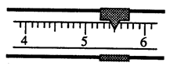
What is the mass of the iron wire?
(A) 0.455 g (B) 0.55 g
(C) 5.5 g (D) 5.50 g

- Which measurement contains four significant figures?
(A) 0.0002 L (B) 0.002 L
(C) 2020 L (D) 2002 L

- What is the correct set-up for the conversion of 950 g to kg?
(A) 950 g x 1000 g (B) 950 g x 1000 kg
1 kg 1 g
(C) 950 g x 1 kg (D) 950 g x 1 g
1000 g 1000 kg

The following tables are used in the problem below.
- 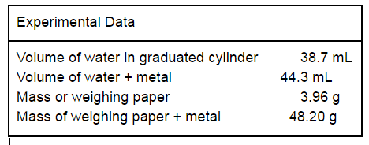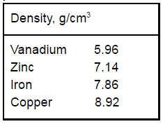

Based on the given data, what kind of metal was used in this experiment?
(A) zinc (B) iron
(C) copper (D) vanadium

Unit 2 Practice

- A sample of material, which has a definite volume but no definite shape
(A) is a solid. (B) is a liquid.
(C) is a gas. (D) does not exist.

- Which is a chemical change?
(A) evaporating alcohol (B) burning butter
(C) melting ice cubes (D) forming fog
- Which of the following microscopic representation shows a homogeneous mixture?
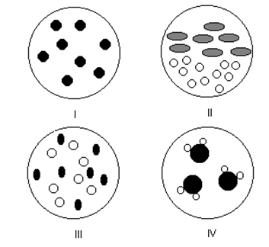
(A) I (B) II (C) III (D) IV

- Which state of matter describes a precipitate?
(A) liquid (B) gas (C) plasma (D) solid (E) aqueous

- Which of the following is an example of a chemical change?

(A) Ice cracking
(B) Sugar dissolving
(C) Milk souring
(D) Lead melting
- Which property is always conserved during a chemical reaction?
(A) mass (B) volume (C) pressure (D) solubility

- Which statement describes a chemical property of iron?
(A) Iron can be flattened into sheets.
(B) Iron conducts electricity and heat.
(C) Iron combines with oxygen to form rust.
(D) Iron can be drawn into a wire.

- Which of the following is NOT an intensive physical property for bromine

- Bromine has a reddish brown color
- Bromine is a liquid at room temperature
- Bromine has a density of 3.1 g/cm³
- Bromine has a volume of 5.00 L

- The weather man has just confirmed that this holiday season 5250.00 g of snow will fall from the sky. If the mass of the oxygen gas in the sky is 787.90 g. What mass of hydrogen gas was in the sky? Remember that snow is solid water.

(A) 6037.90 g
(B) 4462.10 g
(C) 6.6633 g
(D) 0.15007 g

Unit 3 Practice

- Which of the following elements cannot be classified as a nonmetal or metaloid?
(A) Arsenic, As
(B) Sodium, Na
(C) Boron, B
(D) Bromine, Br
(E) Oxygen, O
- Which set of elements contains transition elements?
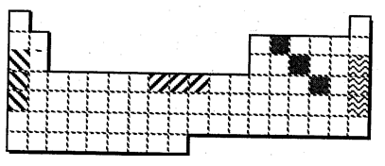
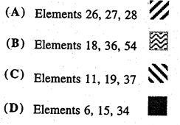

- An isotope differs from other isotopes of the same element,
(A) only by number of electrons
(B) only by number of protons.
(C) by atomic number.
(D) only by mass number.
(E) by mass number and number of neutrons.

- If atoms of a metallic element (such as sodium) react with atoms of a nonmetallic
element (such as sulfur), which element loses electrons and which element gains
them?
(A) metallic element gains and non-metallic element loses electrons
(B) both gain electrons
(C) metallic element loses and non-metallic element gains electrons
(D) both lose electrons

- On the periodic table, where are the nonmetals located?
(A) upper right (B) lower right
(C) upper left (D) lower left

The hypothetical element X has two isotopes.
Isotope Isotopic Percentage of Naturally
Mass (amu) Occurring Isotope
⁴⁰X 39.997 30.1%
⁴⁵X 44.995 69.9%

- What is the average atomic mass of element X?
(A) 45.0 amu (B) 43.5 amu
(C) 42.5 amu (D) 40.0 amu

- The ion of potassium-42, ⁴²K⁺, contains
¹⁹
(A) 18 protons, 19 electrons, and 24 neutrons.
(B) 19 protons, 18 electrons, and 22 neutrons.
(C) 19 protons, 19 electrons, and 23 neutrons.
(D) 19 protons, 18 electrons, and 23 neutrons.

- What is the composition of one atom of bromine-80?

(A) 45 protons, 35 neutrons, 45 electrons
(B) 35 protons, 45 neutrons, 35 electrons
(C) 35 protons, 45 neutrons, 80 electrons
(D) 80 protons, 80 neutrons, 35 electrons

- How many neutrons are present in an ion of ⁷⁵As³⁻?
³³
(A) 108 (B) 75 (C) 42 (D) 33

- The quantum mechanical model of the atom
(A) Defines the exact path of an electron around the nucleus
(B) Was proposed by Niels Bohr.
(C) Is concerned with the probability of finding an electron in a certain position.
(D) Has many analogies in the visible world.

Unit 4 Practice

- One of the emission lines associated with the hydrogen atom has a frequency of 3.23 x 10¹⁵ Hz. What is the energy associated with a photon of this frequency?

(A) 2.14 x 10⁻¹⁸ J
(B) 2.14 x 10⁻¹⁹ J
(C) 6.25 x 10⁻³² J
(D) 1.86 x 10⁻³² J

- A popular radio station broadcasts with a frequency of 9.87 x 10⁷ Hz. What is the
wavelength (in meters) of the broadcast?
(A) 2.96 x 10¹⁶ m
(B) 3.04 x 10⁶ m
(C) 2.96 x 10¹⁰ m
(D) 6.54 x 10⁻²⁶ m

- Which atom contains a partially filled 3p orbital?

(A) iron (B) calcium (C) argon (D) aluminum (E) boron
- What is the maximum number of electrons allowed in an orbital?

(A) 1 (B) 2 (C) 3 (D) 6 (E) 10
- Which element has the electron configuration 1s22s22p63s23p6 4s²3d¹⁰?

(A) zinc (B) chromium (C) copper (D) manganese
- What is the electron dot diagram for the nitrogen atom?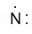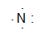
(A) (B) (C) (D)

- Which is the electronic configuration for the scandium atom, Mn ?
(A) [Ne]3s23p3
(B) [Ar]4s2
(C) [Kr]
(D) [Ar]4s23d5
- An atom has atomic number 13 and mass number 27. The number of valence
electrons is
(A) 2 (B) 3 (C) 4 (D) 5 (E) 13
- Which group represents particles with the same number of electrons?

(A) F, Ne, Na (B) Mg⁺², Al, Si⁺⁴ (C) Cl⁻, Ar, K⁺
(D) O²⁻, S²⁻, Se²⁻ (E) Ca⁺², Fe⁺², Cd⁺²

10. What is the electron configuration for the sodium ion?
(A) 1s21p62s22p6 (B) 1s22s22p6
(C) 1s22s22p63s2 (D) 1s22s22p63s1

11.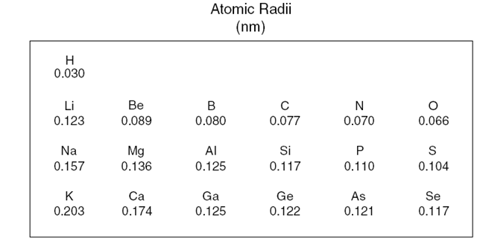
The table shows the atomic radii of some elements in Periods 1 through 4 of the periodic table. Which inference can be made from this information?

(A) Atomic radii double from top to bottom.
(B) Atomic radii increase from bottom to top.
(C) Atomic radii decrease from right to left.
(D) Atomic radii decrease from left to right.

12. Consider a plot of a property of the alkaline earth metals.
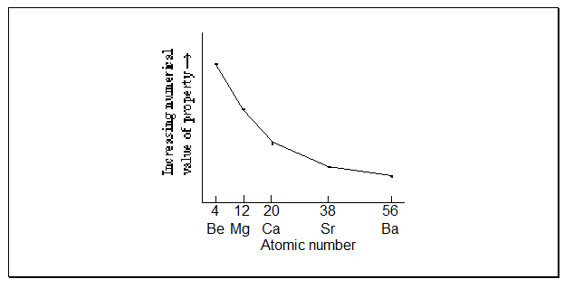
Which property is plotted on this graph?
(A) ionization energy
(B) atomic radius
(C) atomic mass
(D) number of valence electrons

Unit 5 Practice

- Elements Q and T are on opposite sides of the periodic chart. This indicates that in the compound QT
(A) Q and T are widely separated in atomic number.
(B) there is a polyatomic ion present.
(C) the bond is principally molecular (covalent) in character.
(D) the bond is principally ionic in character
- In an ionic compound that the “goal” (or end result) is for the compound to have a ________________ charge.

(A) positive
(B) negative
(C) neutral
(D) large
(E) small

- The correct formula for iron (III) sulfate is
(A) FeSO4 (B) Fe2(SO4)3
(C) Fe(SO4)2 (D) Fe3(SO4)2
(E) Fe2SO4

- Which formula represents the compound diphosphorus pentasulfide?
(A) P₂S (B) PS₂ (C) P₄S (D) P₂S₅
- Which formula is followed by its correct name?

(A) FeCl3, iron(III) chloride
(B) FeS, iron(II) sulfite
(C) Mg3N2, magnesium nitrite
(D) KNO2, potassium nitrate

- The formula for ytterbium nitrate is Yb(NO3)3. What is the formula for ytterbium chloride?

(A) YbCl2 (B) Yb2Cl3 (C) Yb2Cl2 (D) YbCl3

- What is the formula for copper (II) chloride?
(A) CuCl (B) CuCl₂ (C) Cu₂Cl₂ (D) Cu₃Cl₂ (E) Cu₂Cl

- What is the name of (NH₄)₂SO₄?
(A) ammonia sulfite
(B) ammonium sulfate
(C) ammonium sulfite
(D) ammonia sulfate
(E) diammonia sulfur tetroxide

- What type of bond exists in calcium oxide, CaO?
(A) covalent (B) ionic
(C) hydrogen (D) metallic

- What is the formula for diarsenic trioxide?
(A) As₂(O₂)₃ (B) As₃(O₂)₂
(C) As₂O₃ (D) As₃O₂

Unit 6 Practice

- The percentage of hydrogen in NH₄OH is

(A) 5.00% (B) 35.0% (C) 14.3% (D) 11.4% (E) 25.7%

- What is the smallest representative unit for Al₂O₃?
(A) atoms (B) molecules
(C) formula units (D) moles

- A compound consists of 36.5% sodium, 25.4% sulfur and 38.0% oxygen. What is its empirical formula?

(A) Na₂SO₄ (B) NaS₂O₄ (C) Na₂SO₃ (D) Na₂(SO₄)₂
- How many atoms are in one molecule of acetone, CH₃COCH₃?

(A) 1 (B) 6 (C) 3 (D) 10

- Which is an empirical formula?

(A) N2O4 (B) P4O10 (C) Hg2I2 (D) Al2O3

- What is the molecular formula for a compound whose empirical formula is CH₄O and molar mass is 96.0 g/mole.
(A) C₄H₁₆O₄ (B) C₃H₁₂O₃
(C) C₂H₈O₂ (D) CH₄O

- What is the number of molecules in 4.4 g of carbon dioxide?
(A) 1.0 x 10²² (B) 6.0 x 10²² (C) 6.0 x 10²³ (D) 6.0 x 10²⁴

- What is the approximate molar mass of ammonium thiosulfate, (NH₄)₂S₂O₃?
(A) 148 g/mole (B) 134 g/mole
(C) 102 g/mole (D) 61 g/mole

- At STP, what is the mass of 5.00 L of nitrogen gas, N₂(g)?

(A) 6.25 g (B) 3.13 g
(C) 1.25 g (D) 0.625 g

- Which expression gives the number of moles in 175 g sucrose?

(A) 175 g C₁₂H₂₂O₁₁ x 1 mole C₁₂H₂₂O₁₁
342 g C₁₂H₂₂O₁₁
(B) 175 g C₁₂H₂₂O₁₁ x 342 g C₁₂H₂₂O₁₁
1 mole C₁₂H₂₂O₁₁
(C) 175 g C₁₂H₂₂O₁₁ x 342 g C₁₂H₂₂O₁₁ x 6.02 x 10²³ molecules C₁₂H₂₂O₁₁
1 mole C₁₂H₂₂O₁₁ 1 mole C₁₂H₂₂O₁₁

(D) 175 g C₁₂H₂₂O₁₁ x 1 mole C₁₂H₂₂O₁₁ x 6.02 x 10²³ molecules C₁₂H₂₂O₁₁
342 g C₁₂H₂₂O₁₁ 1 mole C₁₂H₂₂O₁₁

Unit 7 Practice

- What is the correct equation for the following scenario: “Solid sodium
chlorate decomposes into solid sodium chloride and oxygen gas.”
(A) 2 NaClO₃ (s) 2 NaClO₂ (s) + O₂ (g)
(B) NaClO₃ (s) NaClO₂ (s) + O (g)
(C) 2 NaClO₃ (s) 2 NaCl (s) + 3 O₂ (g)
(D) 2 NaClO₂ (s) + O₂ (g) 2 NaClO₃ (s)
(E) NaClO₄ (s) NaCl (s) + 2 O₂ (g)

- Which reactants produce Al₂(SO₄)₃ by double replacement?
(A) Al + H₂SO₄ (B) AlSO₂ + O₂
(C) Al₂O₃ + SO₂ (D) AlCl₃ + H₂SO₄

- What are the products of the complete combustion of propane, C₃H₈, in oxygen?
(A) carbon monoxide, CO, and hydrogen, H₂
(B) carbon monoxide, CO, and water, H₂O
(C) carbon dioxide, CO₂, and hydrogen, H₂
(D) carbon dioxide, CO₂, and water, H₂O

- The type of reaction illustrated by the equation below is _____.

HC₂H₃O₂ (aq) + LiOH (aq) H₂O (l) + LiC₂H₃O₂ (aq)

(A) synthesis
(B) decomposition
(C)combustion
(D) precipitation
(E) acid-base neutralization

- Which of the following skeleton reactions is incorrect?
(A) F₂ (g) + KI (aq) KF (aq) + I₂ (s)
(B) SiF₄ (l) + H₂O (l) Si(OH)₄ (s) + HF (aq)
(C) H₂SO₄ (aq) + NaOH (aq) Na₂S (aq) + H₂O (l)
(D) C₅H₁₂ (g) + O₂ (g) CO₂ (g) + H₂O (g)
(E) Na (s) + Cl₂ (g) NaCl (s)

- What is the coefficient of oxygen, O₂, in the balanced equation?
2 C₂H₆ (g) + ? O₂ (g) 4 CO₂ (g) + 6 H₂O (l)
(A) 3 (B) 4 (C) 6 (D) 7

- Which equation best represents the decomposition of solid aluminum oxide when electricity is passed through it?

(A) 2 AlO (s) 2 Al (s) + O₂ (g)
(B) AlO (s) Al (s) + O (g)
(C) 2 Al₂O₃ (s) 4 Al (s) + 3 O₂ (g)
(D) Al₃O₂ (s) 3 Al (s) + O₂ (g)
(E) 3 Al (s) + O₂ (g) Al₃O₂ (s)

- Which set of coefficients will balance this equation?
? ZnS (s) + ? O₂ (g) ? ZnO (s) + ? SO₂ (g)
(A) 1, 1, 1, 1 (B) 1, 2, 1, 1
(C) 2, 3, 2, 2 (D) 2, 5, 2, 2

- This table summarizes the results when solutions are added as indicated.

Solutions | KOH | K₂SO₄
FeCl₃ | Precipitate Occurs | No Precipitate
Zn(NO₃)₂ | Precipitate Occurs | No Precipitate

Which substance is a precipitate?
(A) Fe₂(SO₄)₃ (C) Zn(OH)₂
(B) Fe(NO₃)₃ (D) KNO₃

