VSEPR

(Valence Shell Electron Pair Repulsion Theory)

Lewis structures look at molecules in a two dimensional way; however molecules are NOT two dimensional. Many of the properties of molecular compounds depend on the three dimensional shape of the molecule. The shape of a molecule is predicted by using the VSEPR theory:
____________________________ the electrostatic repulsion between the valence level electron pairs surrounding an atom causes these pairs to be oriented as far apart as possible.

To use VSEPR theory:
- Draw the lewis structure for the molecule.
- Determine the areas of electron density
- Of the areas of electron density, determine the number of lone pairs on the central atom.

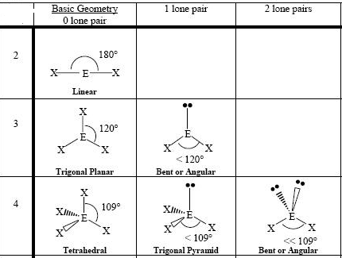
Areas of
electron density

What do lone pairs of electrons on the central atom do to the bonds?

Number of Links on  Central Atom | Number of Lone Pairs  on Central Atom | Shape of Molecule
2 | 0 | Linear
3 | 0 | Trigonal Planar
2 | 1 | Bent
2 | 2 | Bent
4 | 0 | Tetrahedral
3 | 1 | Trigonal Pyramidal

Determine the lewis structure and the VSEPR shape of the following:
- PH₃ Lewis Structure
N
A
S |  |  | bonds
L |  |  | Lone Pairs

Shape:

2. CCl₄ Lewis Structure
N
A
S |  |  | bonds
L |  |  | Lone Pairs

Shape:

3. ClO₂⁻¹ Lewis Structure
N
A
S |  |  | bonds
L |  |  | Lone Pairs

Shape:

Homework: VSEPR and Molecular Geometry

NASL, Draw the Lewis Structure for each compound or ion, and give its shape for the following below:

1. Br₂  Shape: | 5. SO3  Shape:
2. CS2  Shape: | 6. SF₂  Shape:
3. FO3-  Shape: | 7. HF  Shape:
4. SiH4  Shape: | 8. H₂CO  Shape:

