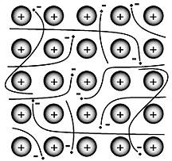**Metallic and Ionic Bonds**

**Metallic bonds** are between metals wherean atom achieves a more stable

configuration by sharing valence electrons with many other atoms.

Properties include:

* Luster, malleability, ductility
* Conductors of heat and electricity in the solid state
* Do NOT dissolve in water (usually denser than water)
* High melting points

Ionic Bonds

A **­­­­___________________________________________________** is a force that holds atoms together.

According to the **octet rule**, atoms form bonds with other atoms so that they will have 8 valence electrons in their outer energy level. Because completed outer energy levels are the **most stable** with **lower potential energy**, elements without eight valence electrons react with other elements in order to fill their outer energy level. Therefore, they attain a **_______________________________________________** configuration.

Some atoms bond with many different substances, others do not. Whether a substance bonds with another substance depends on the number of **_______________________________________________** each substance has. There are two ways that atoms may complete their outer energy levels: they can **transfer** valence electrons or **share** valence electrons.

You can determine the type of bond between two elements by comparing their electronegativities:

* If two elements have similar electronegativities they will share electrons. Covalent bonds occur when electrons are shared.
* If one element has a high electronegativity and another has a low electronegativity they will transfer electrons. Ionic bonds occur when electrons are transferred.

____________________________________: nonmetal + nonmetal (sharing of electrons)

____________________________________: metal + nonmetal (transfer of electrons)

Practice:

1. Mg + Cl 2. S + O 3. H + F

4. Fe + Fe 5. Fe + O 6. Cd + P

## IONIC BONDS

* formed when atoms _________________________________ electrons
* metals tend to lose electron(s) to form __________________________ ions (cations)
* nonmetals tend to gain electron(s) to form ___________________________ ions (anions)
* chemical bond resulting from electrostatic attraction between positive and negative ions
* the resulting chemical compound is called an ionic compound (general name is a **salt**)
* The result is **_______________________________________**
* Also known as a **FORMULA UNIT**

## IONIC BONDING USING LEWIS DOT STRUCTURES

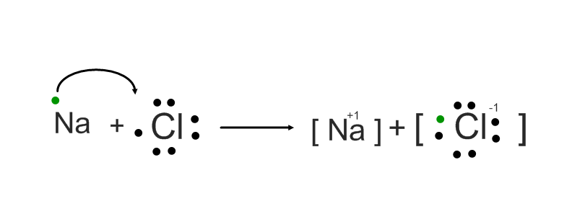Ionic bonding occurs when a metal transfers one or more electrons to a nonmetal in an effort to attain a stable octet of electrons. For example, a Lewis dot diagram can depict the transfer of an electron from sodium to chlorine.

Example 1: Na + Cl

Class Practice:

1. K + S
2. Al + I
3. Mg + N

**Properties of Ionic Compounds:**

* Bond between _____________ and ________________
* Typically exist as ________________ at room temperature
* The solids are very _________________.
* ____________________________ in water
* Ionic bonds are very strong attractions with cause
  + ________ melting points
  + _________ volatility (not easily vaporized)
* ____________________________ of electricity in molten state and/or aqueous state

**HOMEWORK: Ionic Bonds**

*Label each element in the* ***blanks*** *as a METAL OR NONMETAL. Then determine whether they will form an IONIC BOND or a COVALENT BOND in the* ***third blank****.*

|  |  |  |
| --- | --- | --- |
| 1. Na + F  ________ __________  Type of bond __________ | 2. Rb + P  ________ __________  Type of bond __________ | 3. H + Cl  ________ __________  Type of bond __________ |
| 4. Mg + O  ________ __________  Type of bond __________ | 5. Li + N  ________ __________  Type of bond __________ | 6. S + O  ________ __________  Type of bond __________ |

*Draw* ***a Lewis dot diagram representing*** *the electron transfer and the final ion combination.*

7. Li + Cl

8. Ga + P

9. Ca + F

10. Sr + N