Graham’s Law
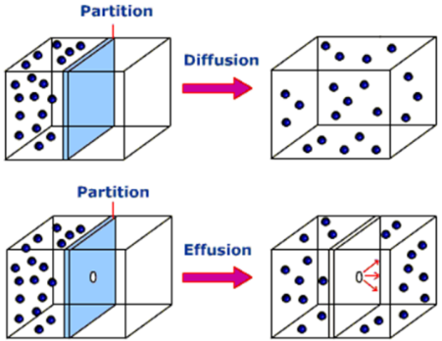
Effusion and Diffusion
- Effusion is the rate a gas escapes through an ________________
in a container.
- Diffusion is the rate at which a gas travels across a room.

If 2 different gases were placed in a container with an opening,
you can always predict which gas will escape through the opening
first or the fastest.

The ________________________ molar mass of the 2 gases will effuse _________________ (1st to escape container).
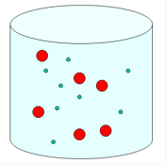
Practice: He or Cl H₂ or Ar Kr or F₂

We can actually calculate the rate of effusion using Graham’s Law of effusion.

Graham’s Law of effusion: effusion rate is ____________________ proportional to the square root of its molar mass.
-Remember, _____________ molecules escape more easily!

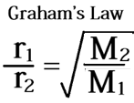

r = the rate of effusion of gas 1 and gas 2
M = molar mass of gas 1 and gas 2
ALWAYS choose the gas with the _________________mass as r₁ because this one moves the fastest!

-Since this equation refers to the RATE of the gas, the answer will show how many TIMES faster gas 1 is compared to gas2.
-Lastly, the only thing you are plugging into this equation is the MOLAR MASS of each gas!

Ex 1) If equal amounts of neon (Ne) and argon (Ar) gases are placed in a porous container and allowed to escape, which gas will escape faster and how much faster?

Ex 2) If there is a hole in a balloon mixed with methane (CH₄) and CO₂ gases, which gas will effuse faster and how much faster?

